WEEK 3:
Product vs services
- Product – tangible
- Services – no ownership of the physical elements involved.
- Services IHIP:
- I – Intangible
- H – Heterogeneus
- I – Inseparable
- P - Perishable
B2C vs B2B
- B2C: Business to customer
- B2B: Business to business
 | B2C | B2B
End customer | individual | business
Number of customers | high | Less and geographically located
Supply chain | larger | Shorter
Purchase duration | Shorter | Longer (3 months – 1yr)
Purchase value | Less | High (millions to billions in currency)
Relationship | Transactional | Collaborative
Price elastic | Yes | No (inelastic)
Ads and promotions | High | Low
Agreements and contracts | Lower | Higher
Decisions maker | Individuals | DMU (decision making unit)

B2B process steps – Buying behaviour:
- Problem recognition – no impulse buying.
Customer firms buy under 2 conditions:
- When there is a problem.
- When there is a need.
- General description of the needs – list of what company needs
- Product specification – based on needs
- Supplier search – based on market research identify and choose vendor(s)
- Analysis and acquisition of proposals – DMU analyses proposals given by suppliers
  - RFI (Request for Information): Used early in the buying process to gather general information about suppliers and possible solutions.
  - RFQ (Request for Quotation): Used when the buyer has clear specifications and asks selected vendors to submit price quotations and proposals.
- Supplier selection – based on analysis supplier selected
- Selection of order routine
- Post usage performance review
B2C – only step which is same as B2B is step 8: post usage performance review.
 | Straight rebuy | Modified rebuy | New task
Products done for | Inexpensive /bought frequently | Some modifications need to be done in the | Expensive/bought for the first time
Number of steps to be done | Don’t have to do all 8 steps |  | All 8 steps need to be done

A straight rebuy is a routine purchase where a buyer repeatedly purchases the same product from the same supplier with little or no modification). It is characterized by frequent, regular purchasing.
Straight rebuy is primarily a B2B (business-to-business) buying situation. It describes an organization repeatedly.
In the B2B buying process, all 8 stages of the buying process (buy phases) are typically followed only in a new task situation, because the organization is purchasing the product or service for the first time and must go through every step.
In a straight rebuy, many of the steps are skipped because it is a routine purchase.
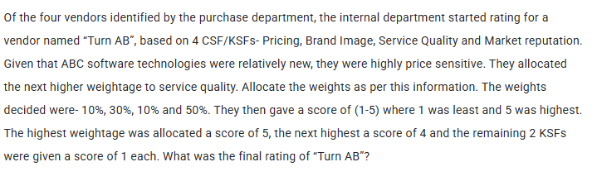

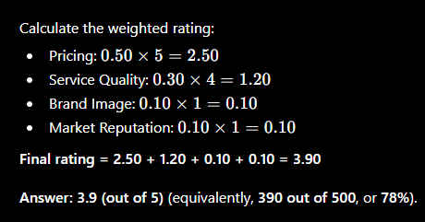
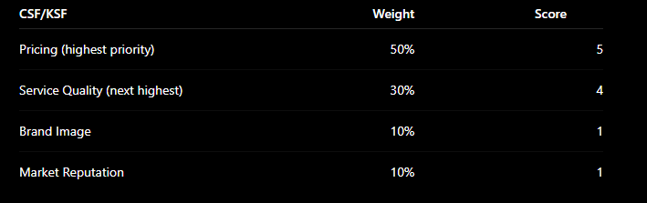

Jilting refers to a customer abandoning a company or brand and switching to a competitor. It is most common in Business-to-Consumer (B2C) markets, where switching between brands is relatively easy. However, it can also occur in Business-to-Business (B2B) markets, although less frequently because of long-term contracts and stronger business relationships.

